GraphPlotter.py

Sample application to plot the graph generated by the Algorithms library on a world map.

GraphPlotter is run via the call python GraphPlotter.py <input_file>. It takes as an argument an input file in the form of a csv.

For Dijkstra’s or Bellman-Ford’s Algorithm the input file should be in the form of <latitude>, <longitude>, <weight>, <Airline Code>.

For Prim’s Algorithm, the input file should be in the form of <latitude>, <longitude>, <weight>, <Airline Code>, <neighbor1>_<neighbors2>_... Values inside neighbor (longitude, latitude, weight, and name) should be separated by semicolons.

For Tarjan’s algorithm, the input file should be in the form of <latitude>, <longitude>, <name>

For Johnson’s algorithm, the input file should be in the form of <latitude>, <longitude>, <weight>, <name>. Sets of paths should be separated by a line that only says the word done on it.

Upon starting the program, the user will be prompted to choose what type of algorithm they would like to use from a list of options:

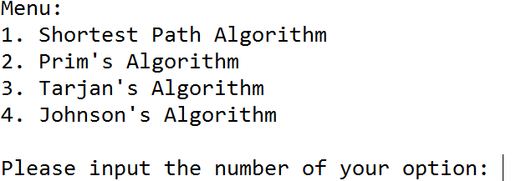

The user will then be prompted to input where their input file is stored:

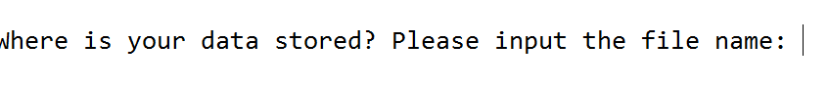

The application will then plot the inputted file.